Receiving funds via email transfer (Plooto)

This document is only relevant to members who have opted to receive Collective Agreement funds, honoraria, or expense via email transfer. If you have asked for a cheque to be cut, it will either be mailed to you or made available for pickup from the union office as per your request.

- Once your funds are ready for you, you will receive an email titled “Action required: Accept your payment from CUPE Local 3903” sent from CUPE Local 3903 via Plooto.
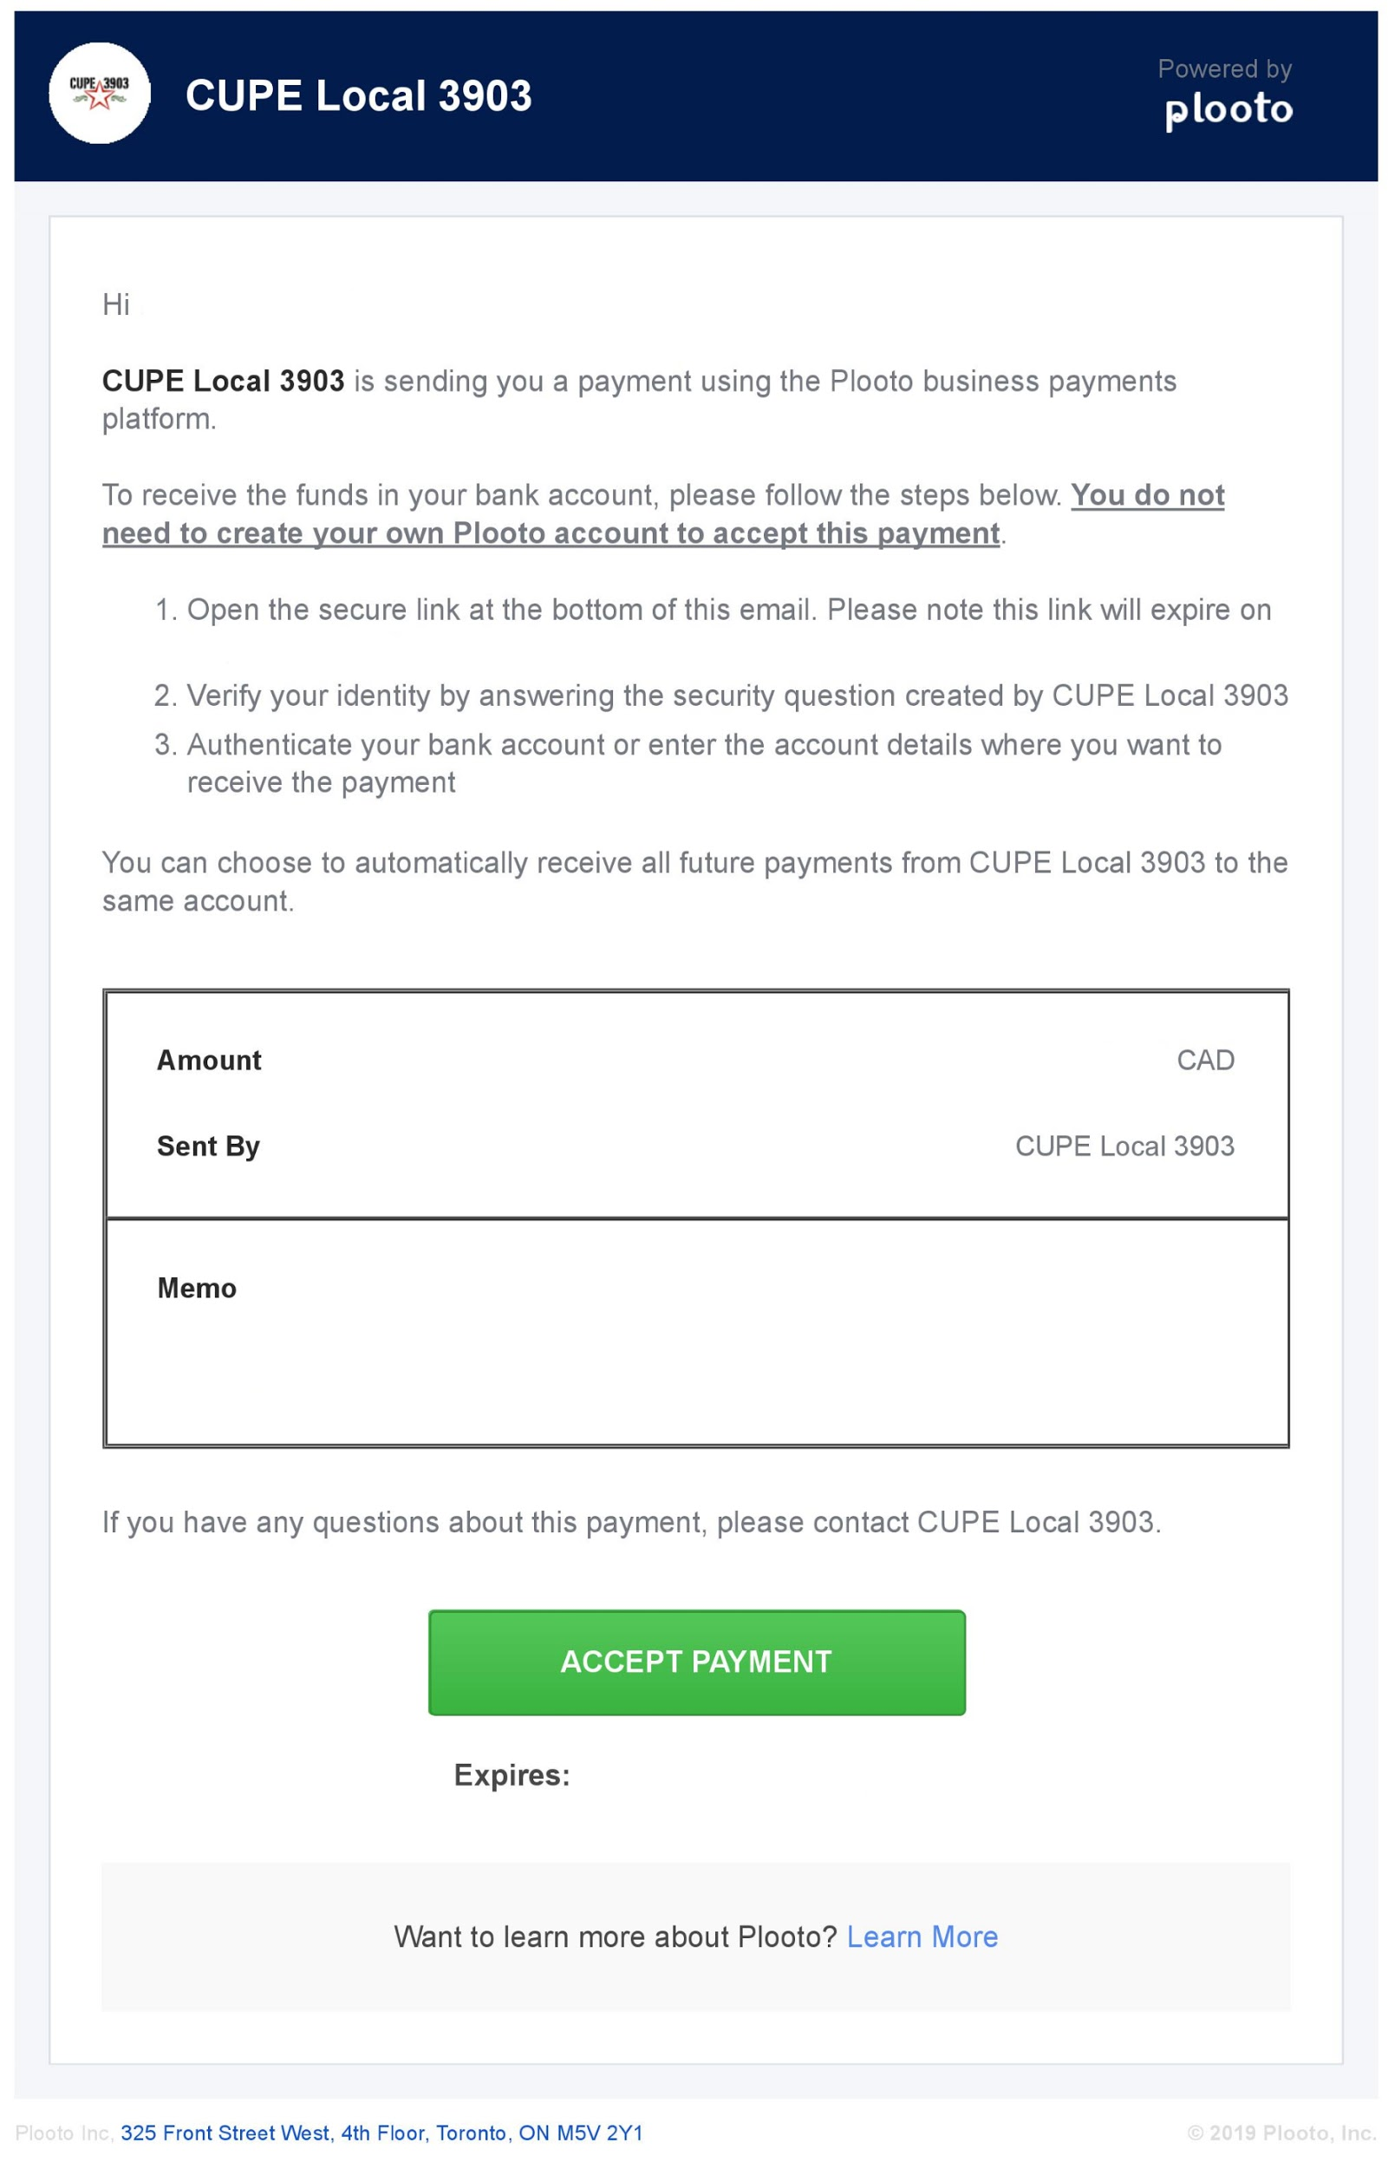
- Once you click “Accept Payment,” you will be presented with a Security Question page. The question will be “What is your YorkU Employee Number?” and the answer will be your YorkU Employee Number. If you are unsure of your Employee Number, please see the appendix of this document.

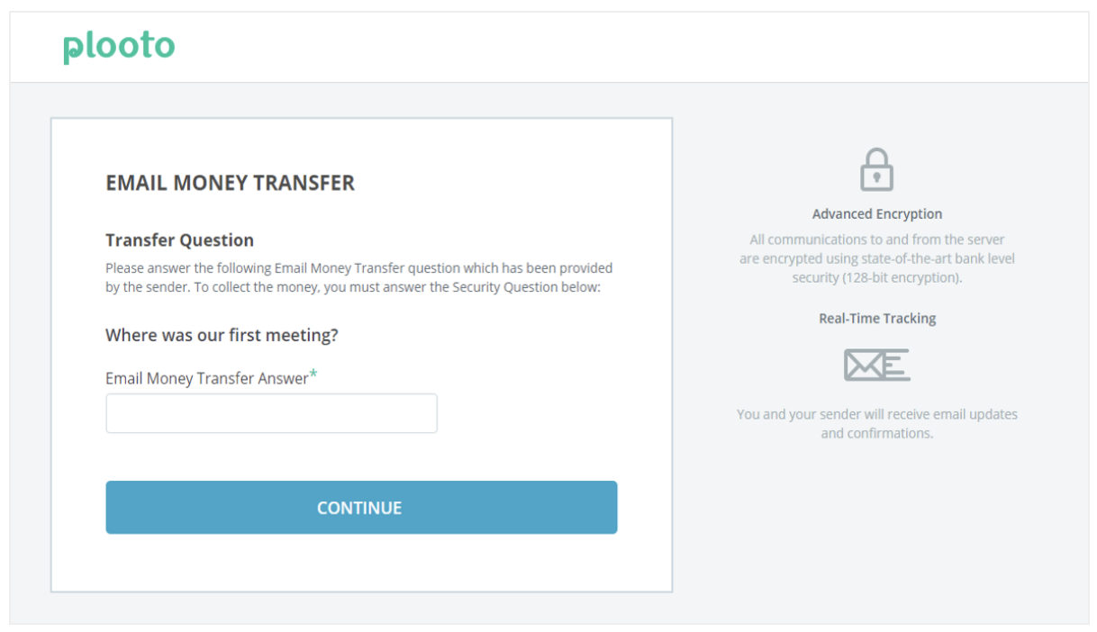
- After correctly answering the Security Question, you will need to provide Plooto with your banking details. If your financial institution appears on the list, you will be able to securely log in to your online banking and your banking details will automatically be provided. Should your financial institution not appear on the list, you will need to manually provide Plooto with your accounts: (1) Transit Number, (2) Institution Number, and (3) Account Number. This information can be found on the bottom of a cheque, on a direct deposit form, or by contacting your financial institution.
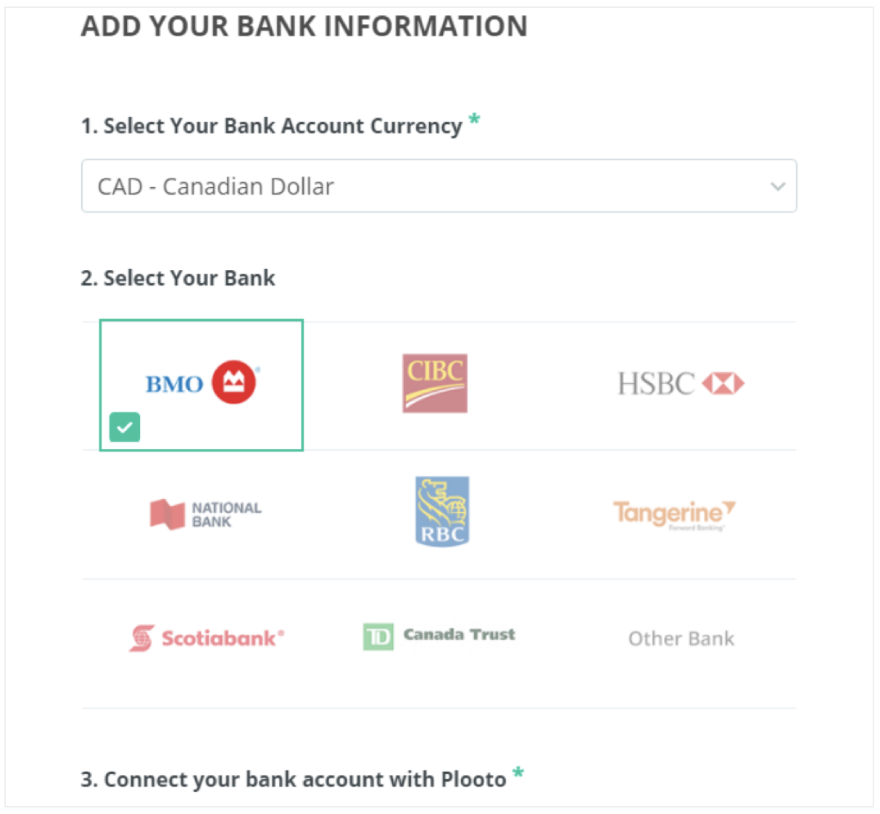

- Now that you have provided Plooto with your banking information, the next step is to accept the transfer. Please confirm that the information you entered is correct. Also, you can opt to allow Plooto to “reuse” your banking information for future transactions.
- You will then see a confirmation screen and will receive a confirmation email. This email will also provide you a link that will allow you to see the status of your payment and a history of payments from the Local through Plooto.
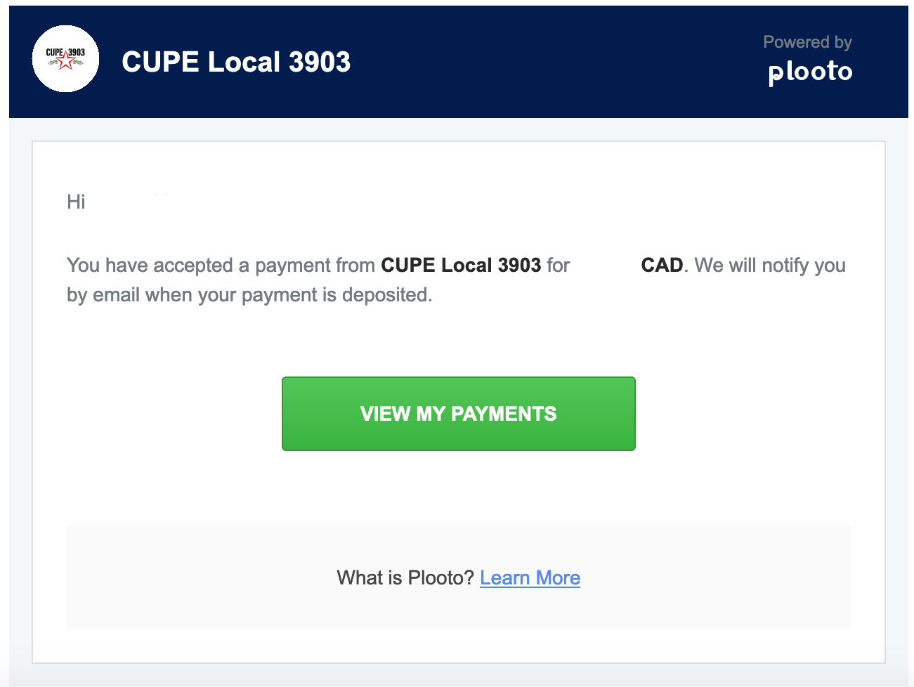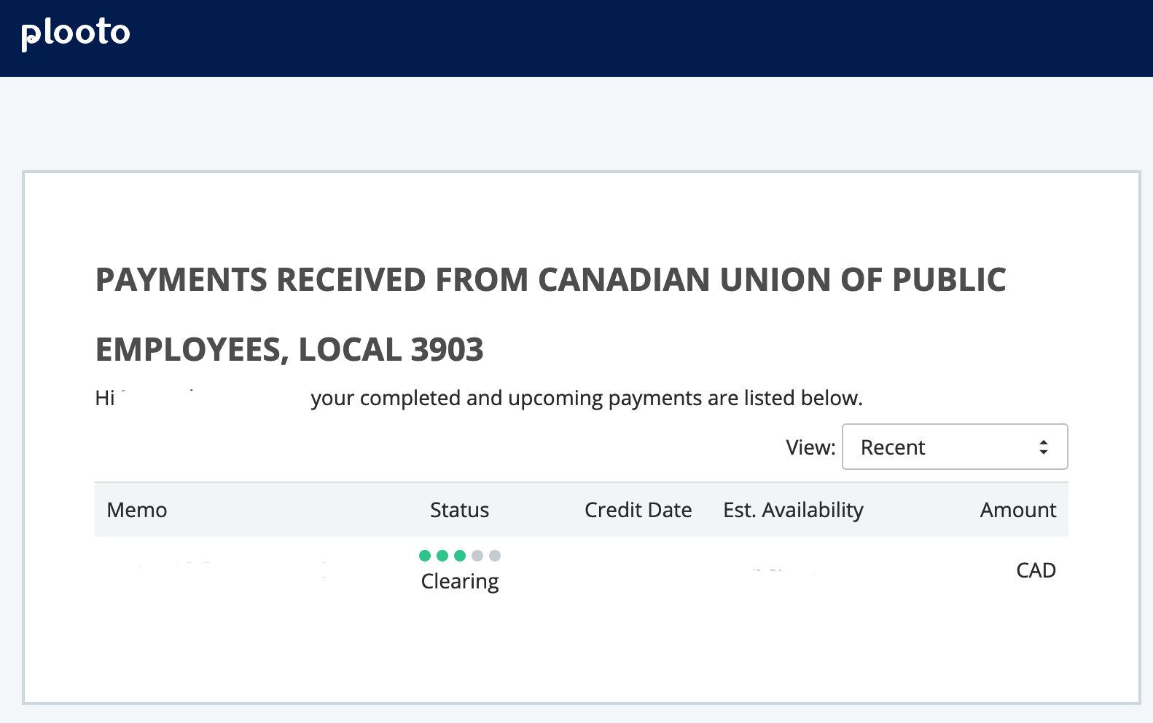

What is my Employee Number?

For members of all units, your Employee Number can be found:
- On your paystub within HR SelfServ
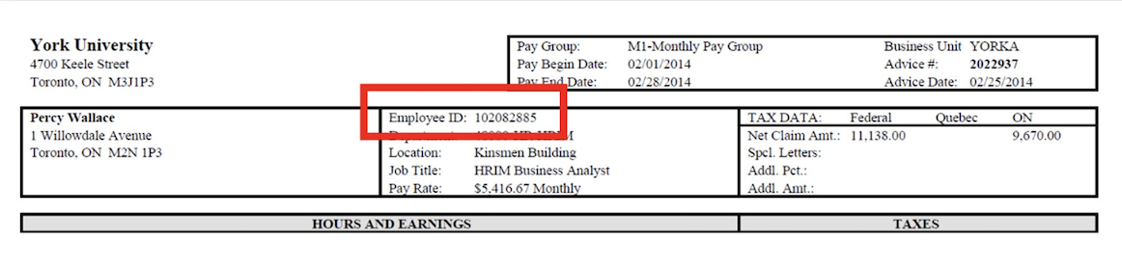
- On your SunLife benefits card
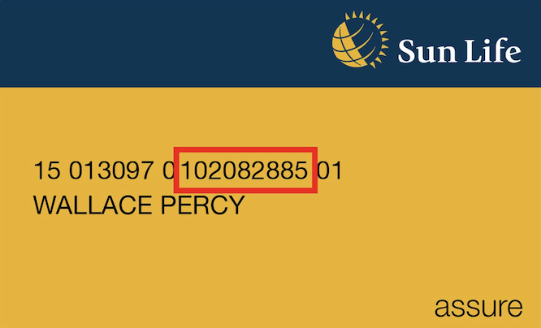

For members of units 1 and 3, your Employee Number can also be found by:
- Contacting your Graduate Program Assistant
- Contacting the Administrative or TA Coordinator within your Hiring Unit

For members of units 2 and 4, your Employee Number can also be found:
- On your YorkU card

